Schools of Interpretation
Four approaches for interpreting Revelation have been distinguished by their understanding of the relationship of the visions to one another and the relationship of the visions to the events of history:
1. Historicism understands the literary order of the visions, especially in 4:1–20:6, to symbolize the chronological order of successive historical events that span the entire era from the apostolic church to the return of Christ and the new heaven and earth.

Historicist School
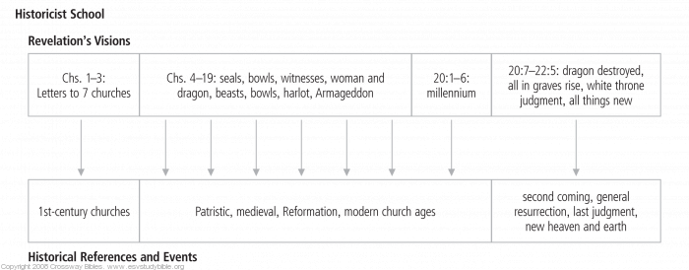
2. Futurism likewise treats the order of the visions as reflecting the order of particular historical events (with some exceptions). Futurists, however, typically view the visions of chapters 4–22 as representing events still future to twenty-first-century readers, thus in a distant future from the standpoint of John and the churches of Asia. For many futurists, these coming events include a discrete seven-year period of intense tribulation (chs. 6–19), followed by a millennium (20:1–6) in which Christ will rule on earth before the general resurrection and the inauguration of the new heaven and earth (20:7–22:5).
(Material Taken from ESV Study Bible “Introduction to Revelation”)

Futurist (Historical Premillennialism)
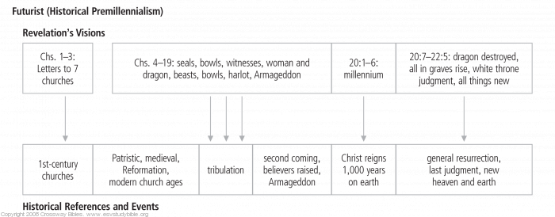

Futurist (Dispensational Premillennialism)
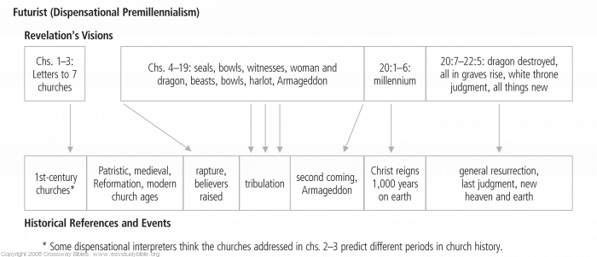
3. Preterism (from Latin praeteritum, “the thing that is past”) thinks that the fulfillment of most of Revelation's visions already occurred in the distant past, during the early years of the Christian church. Preterists think these events—either the destruction of Jerusalem or the decline and fall of the Roman Empire, or both—would “soon take place” only from the standpoint of John and the churches of Asia. Some preterists interpret the order of the visions as reflecting the chronological succession of the events they signify, but others recognize the presence of recapitulation (that is, that distinct, successive visions sometimes symbolize the same historical events or forces from complementary perspectives; see Structure and Outline). Full preterism—which insists that every prophecy and promise in the NT was fulfilled by a.d. 70—is not a legitimate evangelical option, for it denies Jesus' future bodily return, denies the physical resurrection of believers at the end of history, and denies the physical renewal/re-creation of the present heavens and earth (or their replacement by a “new heaven and earth”). However, preterists who (rightly) insist that these events are still future are called “partial preterists.”

Partial Preterist School(s)
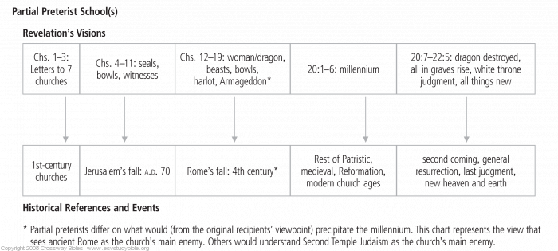
4. Idealism agrees with historicism that Revelation's visions symbolize the conflict between Christ and his church on the one hand, and Satan and his evil conspirators on the other, from the apostolic age to Christ's second coming. Yet idealist interpreters believe that the presence of recapitulation (see Structure and Outline) means that the visions' literary order need not reflect the temporal order of particular historical events. The forces and conflicts symbolized in Revelation's vision cycles manifest themselves in events that were to occur “soon” from the perspective of the first-century churches (as preterists maintain), but they also find expression in the church's ongoing struggle of persevering faith in the present and foretell a still-future escalation of persecution and divine wrath leading to the return of Christ and the new heaven and earth.

Idealist School
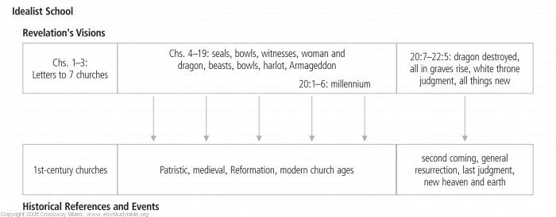
5. Finally, some interpreters hold a mixed view, combining features of these various positions, such as saying that many events have both present and future fulfillments, or saying that many events have past fulfillments but that there may still be a future personal Antichrist.

Millennial Views
Christians disagree on the question of whether the Bible generally and the “thousand years” of 20:1–6 specifically predict a future, interim kingdom in which the Lord Jesus will return bodily to earth to reign with resurrected believers during an era of peace, justice, and physical well-being, before history's consummation in the new heaven and earth. Three views have been maintained.
1. Premillennialism, usually associated with a futurist reading of Revelation (see Schools of Interpretation), teaches that Christ will return bodily in power and glorybefore (pre-) the “thousand years” (millennium) to defeat and destroy the beast and false prophet in the battle on the “great day of God the Almighty” at Armageddon (16:14–16; 19:11–21). This battle will issue in the binding (but not the destruction) of the devil, preventing him from deceiving the nations for a thousand years (interpreted literally by many premillennialists, but symbolically by others) (20:1–3). During that time Christ's saints, having received their immortal bodies either by resurrection from the dead or by transformation of the living (1 Thess. 4:13–18) in the “first resurrection,” will reign with Christ on the present earth, still infected by sin and sorrow but relieved to a significant degree from sin's societal and physical consequences. Although sin, sorrow, and death will not be eliminated until the new heaven and earth displace the first heaven and earth (Rev. 21:1–4; 22:3), the descendants of those who survive the battle of Armageddon will remain on the earth, ruled by resurrected saints, and they will live to extraordinary ages (Isa. 65:20–25). Many premillennialists, especially dispensationalists of various emphases, believe that OT prophecies of Israel's restoration to fidelity and to political and material blessedness will be fulfilled in this millennial kingdom. Although diversity exists among premillennialists regarding the degree to which Revelation's visions and other biblical prophecy should be interpreted “literally” or symbolically, many consider it safer to interpret both the recipients and the content of prophesied blessings as literally as possible, rather than to risk unwarranted symbolism.
At the end of this idyllic foretaste of “paradise restored,” a second worldwide rebellion against Jesus' reign will provoke another war, in which the dragon itself will be defeated and finally destroyed. At that point the wicked will be raised bodily to face God's last judgment and eternal wrath in the lake of fire, the “second death” (20:6, 11–14). God will replace the old, curse-infected heaven and earth with the new heaven and earth, where there will be no curse, sin, suffering, sorrow, or death—the eternal home of those whose names are written in the Lamb's book of life (chs. 21–22).
Classical premillennialism expects a future thousand-year reign of Christ on earth (the millennium), with both believers and unbelievers present, prior to the final judgment. Therefore it expects that Christ will come back before (pre-) the millennium. It also expects that believers will go through a time of “great tribulation” before Christ returns.
Pretribulational premillennialism also expects a future thousand-year reign of Christ on earth, but it expects that Christ will first come secretly to take believers from the earth before a “great tribulation” of seven years occurs. After the tribulation, it expects that Christ will come back publicly to reign on the earth, and that he will bring believers back with him at that time.

Classical Premillennialism
(Christ comes before the millennium but after the tribulation; the chair, in this and following illustrations, represents the judgment seat of Christ)
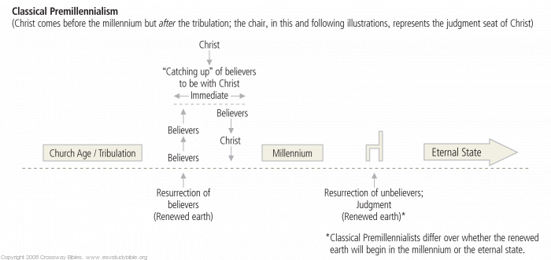

Pretribulational Premillennialism
(Christ comes before the millennium and before the tribulation)
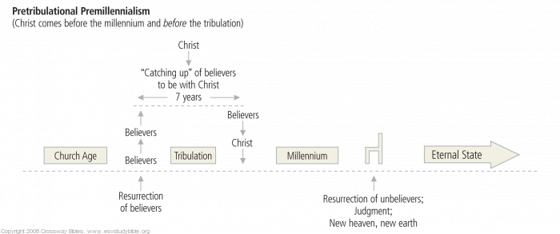
2. Postmillennialism, often associated today with preterism but also compatible with historicism (see Schools of Interpretation), teaches that Christ will return after(post-) the “thousand years” in which the dragon is bound. Classical postmillennialism holds that the “thousand years” is still a future time, a wonderful coming age in which the gospel will triumph so greatly as to thoroughly transform the world's societies and cultures. However, a few postmillennialists think the “thousand years” symbolically portray the historical epoch that began with Christ's ascension and that conditions in this long period will continually improve until they conclude with his glorious second coming. In the postmillennial view, during the millennium Christ is in heaven, not on earth; but he exercises his reign through his Spirit and the church's preaching of the gospel. The “first resurrection” is believers' spiritual transition from death to life through union with the risen Christ (Eph. 2:4–6). Because Satan cannot “deceive the nations any longer” (Rev. 20:3), the church's mission will result in the conversion of all nations and peoples, until the earth is “filled with the knowledge of the glory of the Lord as the waters cover the sea” (Hab. 2:14). This fruit of Jesus' victory will be plain for all to see, as political and legal systems are conformed to God's righteousness, cultural pursuits such as labor and the arts are redeemed, and increasing quality and length of life are displayed as God's blessing.
After this “millennium,” however, for a brief interval before Jesus' return, God will release his restraint on Satan and wicked humanity will converge in a defiant assault on Christ's church. But Jesus will return bodily from heaven in power and glory to defeat and destroy his enemies, to administer the last judgment, and to introduce the new heaven and earth, untainted by sin and its toxic byproducts, in the eternal state.

Postmillennialism
(Christ comes after the millennium)
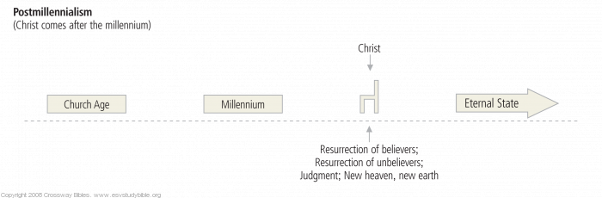
3. Amillennialism, typically advocated by idealists but consistent with some expressions of preterism or historicism (see Schools of Interpretation), concurs with postmillennialism that Christ will return after the epoch symbolized as “a thousand years” (20:1–6) and that OT prophecies and Revelation's visions are ordinarily to be understood as symbolizing the blessings and trials of the NT church, composed of believers in Christ from every nation. However, amillennialists believe that the biblical evidence indicates that there is and will be no (a-) millennium in the sense anticipated by premillennialism or postmillennialism before the consummation of history, when sin and curse are utterly banished in the “new heavens and a new earth in which righteousness dwells” (2 Pet. 3:13). Through Christ's death and resurrection Satan was bound, and therefore he is unable to hold the Gentiles in ignorance or gather a worldwide coalition against the church. Therefore the gospel now advances by the Spirit's power through the church's witness, but always amid opposition and suffering. Just as Jesus the Lamb conquered by being slain, so the victory of his church consists in faithfulness “even unto death” (Rev. 5:9; 12:11). The “first resurrection” is, paradoxically, the martyrs' death, which brings them to heavenly thrones from which they now reign with Christ (20:4–5). The “thousand years” vision prepares the church for a long era of witness and suffering between Christ's first coming to bind Satan (Mark 3:26–27) and his return to destroy Satan. It does not promise relief from persecution, nor a general improvement of living conditions on the sin-infected “first earth,” prior to the pristine new heaven and earth. Rather, the vision promises that the dragon, already a defeated foe, cannot thwart God's plan to gather people from all nations into the Lamb's redeemed army.
Invoking recapitulation, amillennialists view Revelation 19:17–21 and 20:9–10 as complementary perspectives on the same last battle at the end of the “thousand years,” when Christ will come bodily and gloriously to rescue his suffering church and destroy its enemies: beasts, dragon, their deceived and defiant followers, and—in the general resurrection of the just and the unjust—death itself (20:14; see 1 Cor. 15:26, 54–55). The “appearing of the glory of our great God and Savior Jesus Christ” is the “blessed hope” for which believers wait (Titus 2:13).

Amillennialism
(No future millennium)
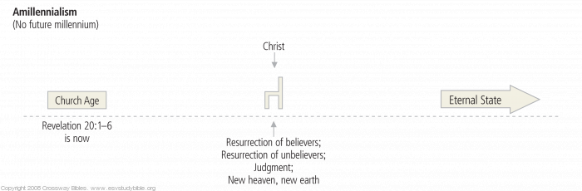
Each of these three primary millennial views falls within the framework of historic Christian orthodoxy. Though they differ in significant ways with regard to the interpretation of the book of Revelation and other passages related to eschatology, each view is well represented among Bible-believing, orthodox Christians.

Notes

